Session ID

🪪 What Is a Session ID?
# Source: AI Source: Provided by: [Data Path: Persons Table -> ID Column: 1, Name_En Column: Motasem Essam] -> From: [ChatGPT] on [2/12/2026]
A Session ID is a unique identifier that a server generates to recognize a specific user's session — like when you log in to a website and the site remembers you as you move between pages.

✅ Simple Definition:
# Source: AI Source: Provided by: [Data Path: Persons Table -> ID Column: 1, Name_En Column: Motasem Essam] -> From: [ChatGPT] on [2/12/2026]
A Session ID is a special key (usually a random string) that lets the server know "this is you" while you're using the site.

🧠 Real-Life Analogy:
# Source: AI Source: Provided by: [Data Path: Persons Table -> ID Column: 1, Name_En Column: Motasem Essam] -> From: [ChatGPT] on [2/12/2026]
Think of a Session ID like a table number at a restaurant:
- You sit at table #12
- Waiters know where to bring your food
- The table number is your session ID

🧾 Example of a Session ID
# Source: AI Source: Provided by: [Data Path: Persons Table -> ID Column: 1, Name_En Column: Motasem Essam] -> From: [ChatGPT] on [2/12/2026]
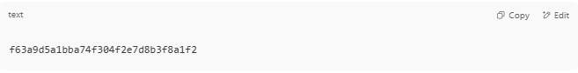
f63a9d5a1bba74f304f2e7d8b3f8a1f2

🔁 How It Works (Basic Web Flow)
# Source: AI Source: Provided by: [Data Path: Persons Table -> ID Column: 1, Name_En Column: Motasem Essam] -> From: [ChatGPT] on [2/12/2026]
- 👤 You visit a website → the server creates a session for you.
- 🧾 It generates a Session ID (random).
- 🍪 The Session ID is saved in your browser as a cookie

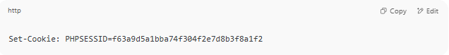
Set-Cookie: PHPSESSID=f63a9d5a1bba74f304f2e7d8b3f8a1f2

- 🔁 On every next request, your browser sends that cookie back.
- 🧠 Server checks the session ID to remember who you are.

💻 Example in PHP
# Source: AI Source: Provided by: [Data Path: Persons Table -> ID Column: 1, Name_En Column: Motasem Essam] -> From: [ChatGPT] on [2/12/2026]
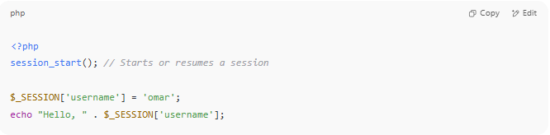

<?php
session_start(); // Starts or resumes a session

$_SESSION['username'] = 'omar';
echo "Hello, " . $_SESSION['username'];

- session_start() creates or resumes the session
- PHP automatically sets and uses PHPSESSID in the background

🧠 What’s Stored in a Session?
# Source: AI Source: Provided by: [Data Path: Persons Table -> ID Column: 1, Name_En Column: Motasem Essam] -> From: [ChatGPT] on [2/12/2026]
Usually:
- Logged-in user ID
- Username
- Shopping cart contents
- Temporary form data

⚠️ Session ID vs Token
# Source: AI Source: Provided by: [Data Path: Persons Table -> ID Column: 1, Name_En Column: Motasem Essam] -> From: [ChatGPT] on [2/12/2026]
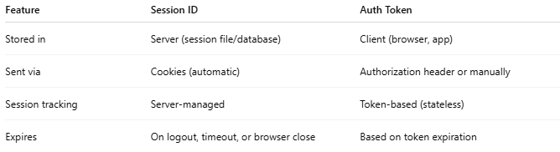

Feature | Session ID | Auth Token
Stored in | Server (session file/database) | Client (browser, app)
Sent via | Cookies (automatic) | Authorization header or manually
Session tracking | Server-managed | Token-based (stateless)
Expires | On logout, timeout, or browser close | Based on token expiration

🔐 Security Tips
# Source: AI Source: Provided by: [Data Path: Persons Table -> ID Column: 1, Name_En Column: Motasem Essam] -> From: [ChatGPT] on [2/12/2026]
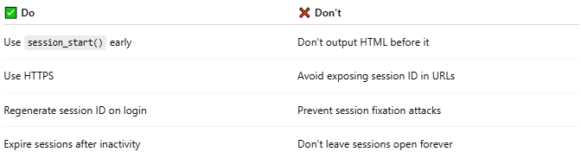
✅ Do | ❌ Don’t
Use session_start() early | Don’t output HTML before it
Use HTTPS | Avoid exposing session ID in URLs
Regenerate session ID on login | Prevent session fixation attacks
Expire sessions after inactivity | Don’t leave sessions open forever

